**Remaining Task List:**

1. Import data from excel to the database.
2. Another User updated message while saving a diagram. Relationship is updated, but the drawing is not properly saved.
3. Search on entire sheet. Highlight text when search complete. Next and Back features.
4. Upload file excel file according to the username.
5. Apply Search bar on saved catalog, Apply sorting on saved catalog.
6. Every column should have a search bar (feature to be added later)
7. Matrix should be created on right click. Not on Menu bar
8. Enlarge dialog box of Matrix and Catalog. Too small.
9. Arrows of different relationships need to be drawn differently.
10. Double click on relationship arrow should open a form.
11. Implement radio buttons as mentioned in the Meta model file.
12. Check if user is allowed to import/ export.
13. Increase the size of dialog box.
14. Matrix
    1. Name
    2. Row
    3. Column
    4. Relation
    5. If a relationship exist then create matrix otherwise show an error.
    6. If a relationship has its own attributes then show their respective properties instead of CRUD.
    7. If relationship has its own relationship then dropdown otherwise tick if relationship exist.

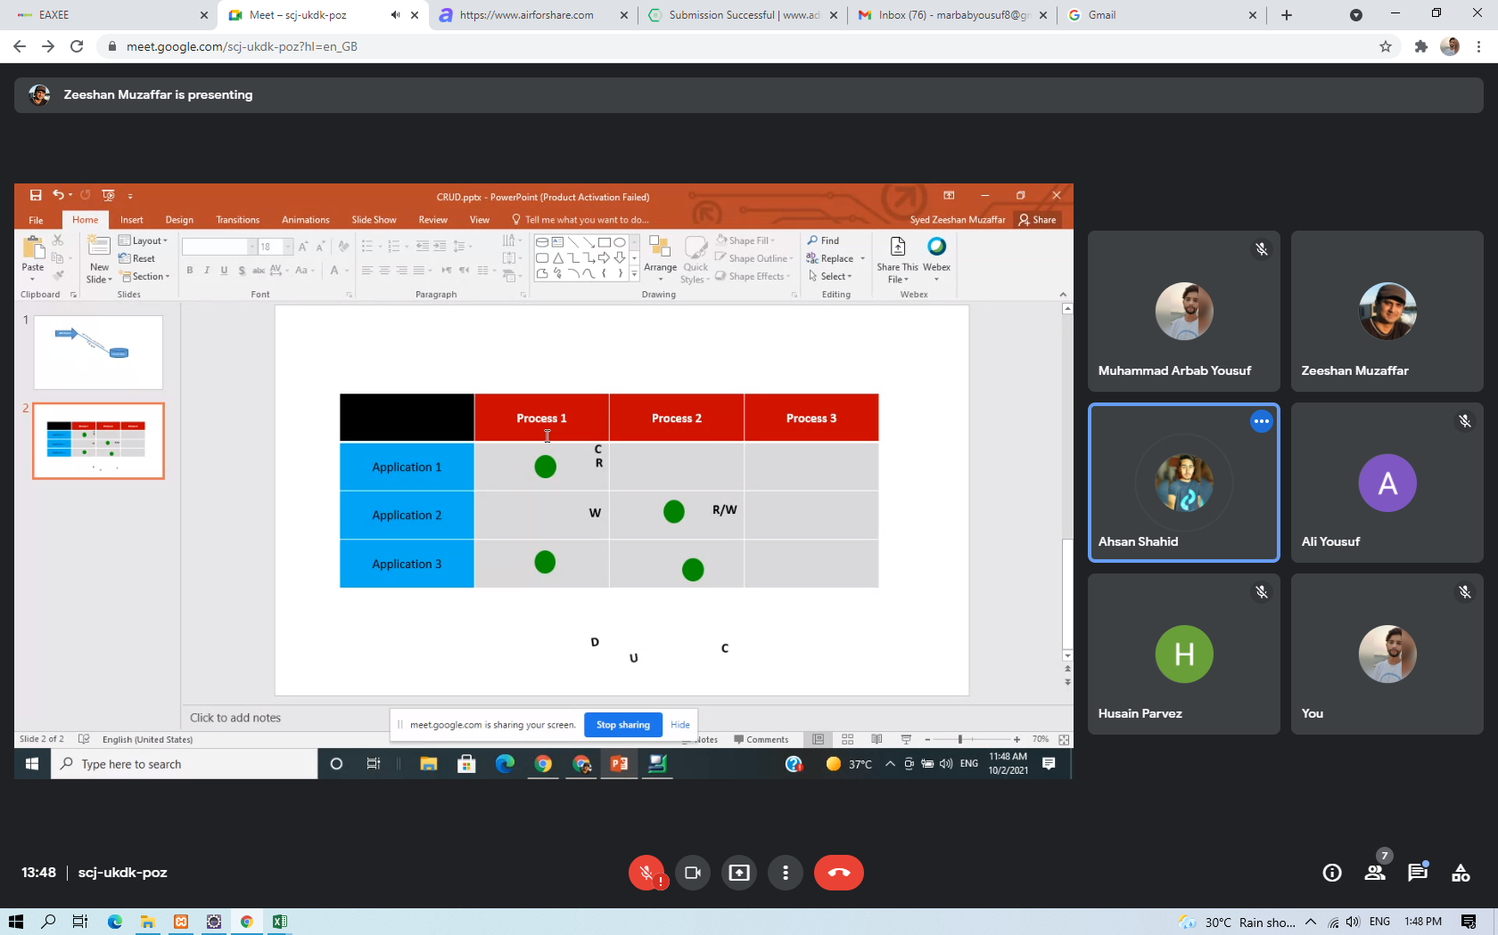

1. Position of CRUD should be same.
2. Based on relationship create matrix.
3. In archimate metamodel there are Read, Write, Read/ Write.
   1. Based on read, write, read/write arrow should be changed.
4. In archimate metamodel we can only select one option at a time by using radio buttons.
5. IN EAXEE metamodel there are create, read, update and delete options.
   1. Based create, read, update and delete the arrow should be like this.

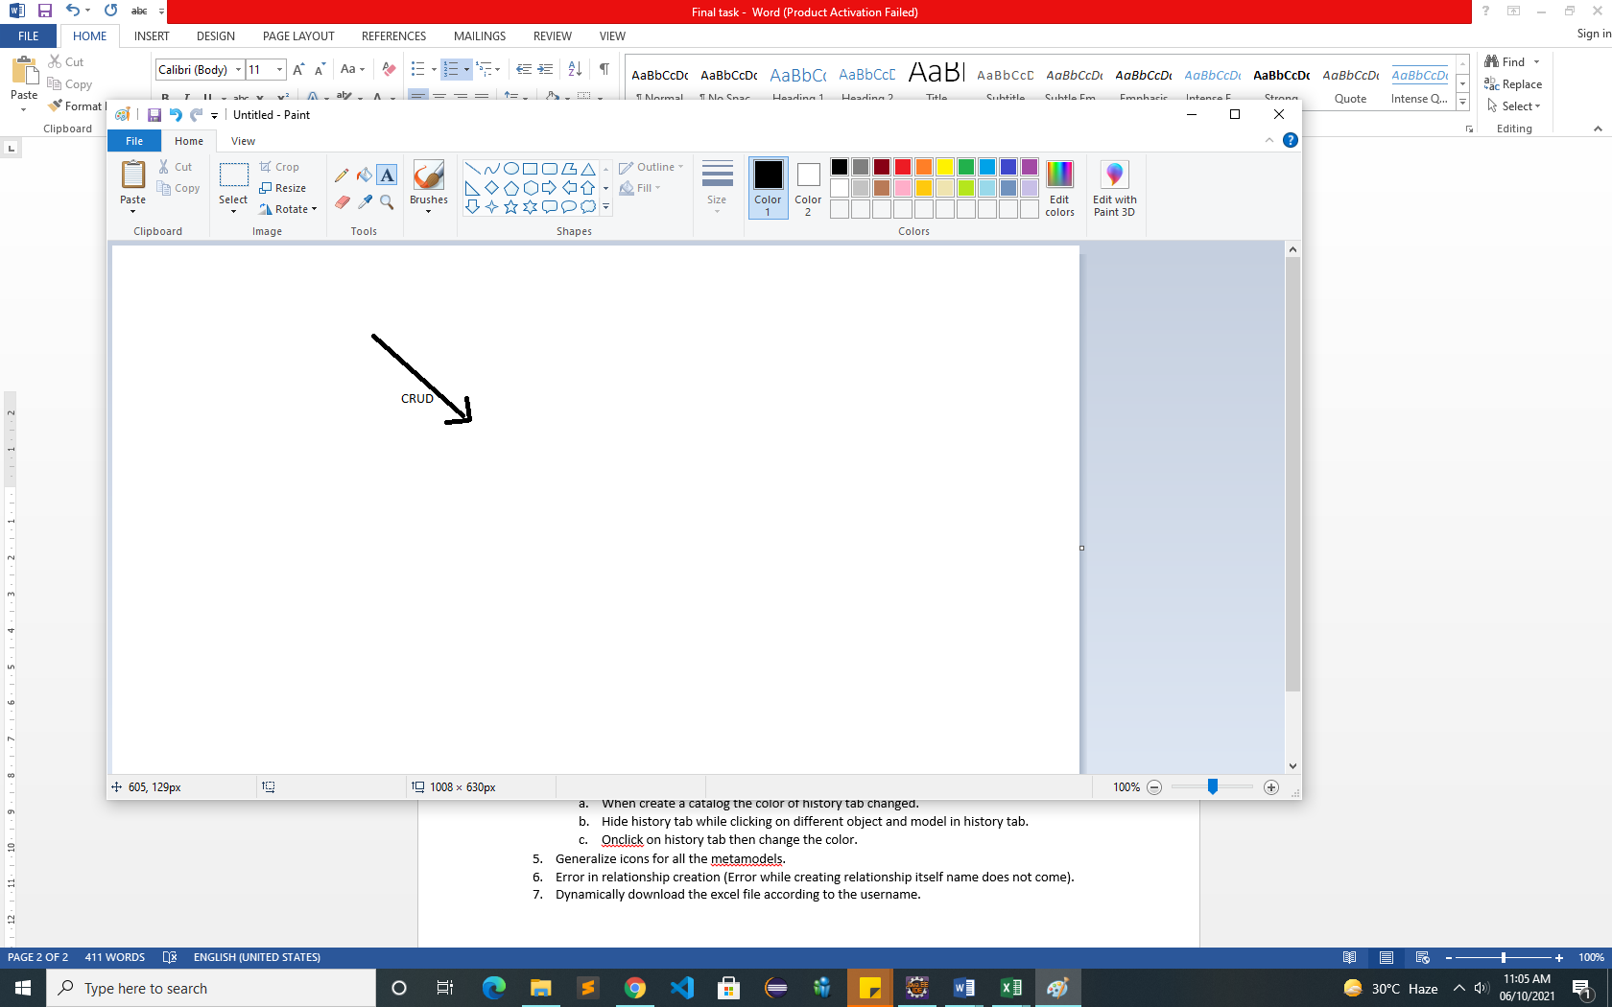

1. Not add more than two alert positioning.
2. In GAP display only two rows.
3. If more than four then scroll bar on relation.
4. Canvas error when moving towards top.
5. Not add more than two records check on the database.
6. Same format for export and catalog if more than one then separate it with “;” in excel.

**Task Completed:**

1. Show only metamodel in the dropdown.
2. Write metamodel name to the database from the registration form.
3. Change database name to <name>_metamodel.
4. Remove history tab bugs for catalog.
   1. When create a catalog the color of history tab changed.
   2. Hide history tab while clicking on different object and model in history tab.
   3. Onclick on history tab then change the color.
5. Generalize icons for all the metamodels.
6. Error in relationship creation (Error while creating relationship itself name does not come).
7. Dynamically download the excel file according to the username.
8. In the Matrix dialog box, use Column, Row only
9. Export data from database to excel.
10. Remove duplicate relationships from relationship folder.
11. Filter Second dropdown according to the first dropdown (In Matrix).
12. Add another dropdown name relationship in the matrix.
13. Add language option in wordpress.

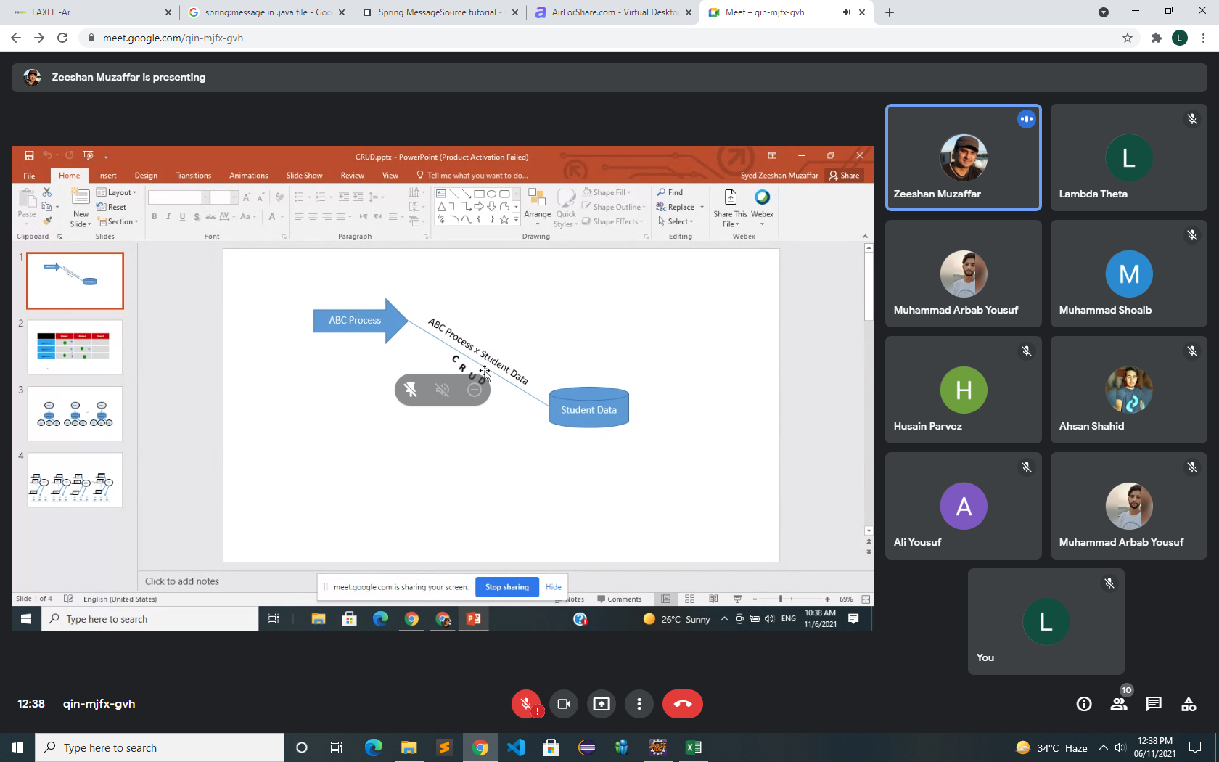

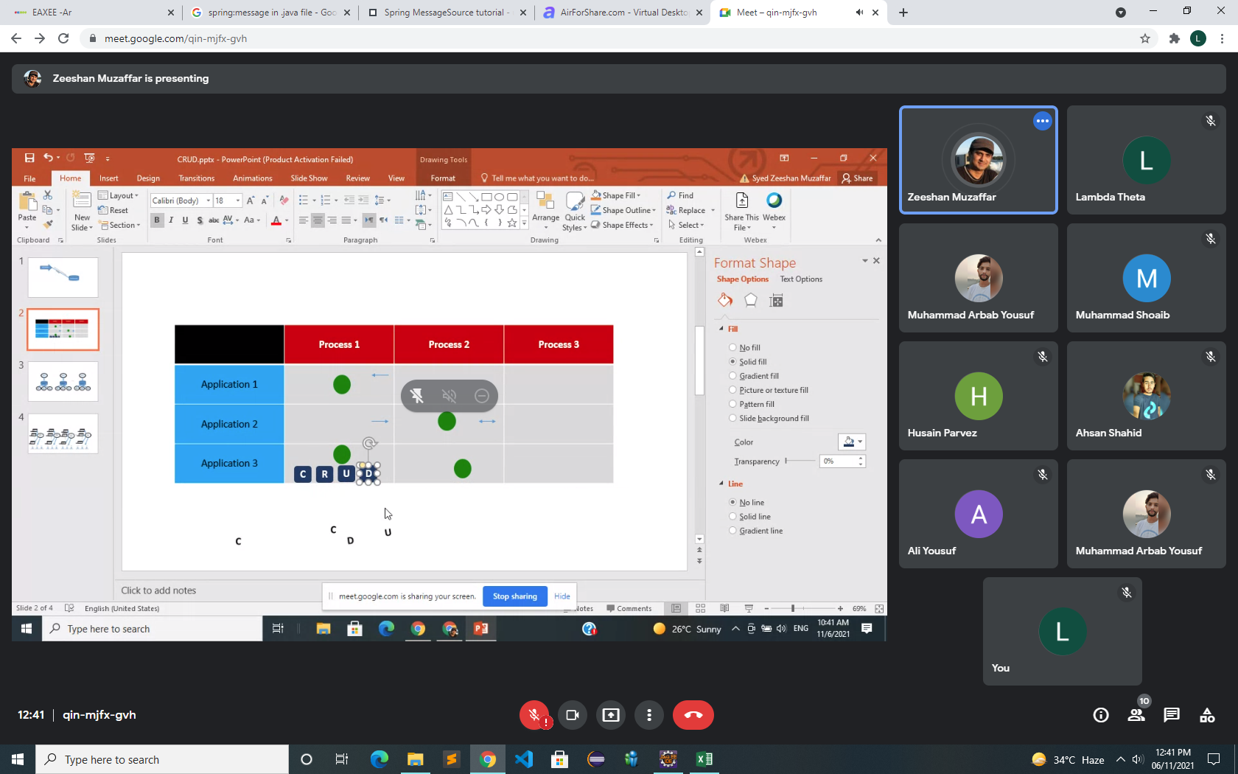

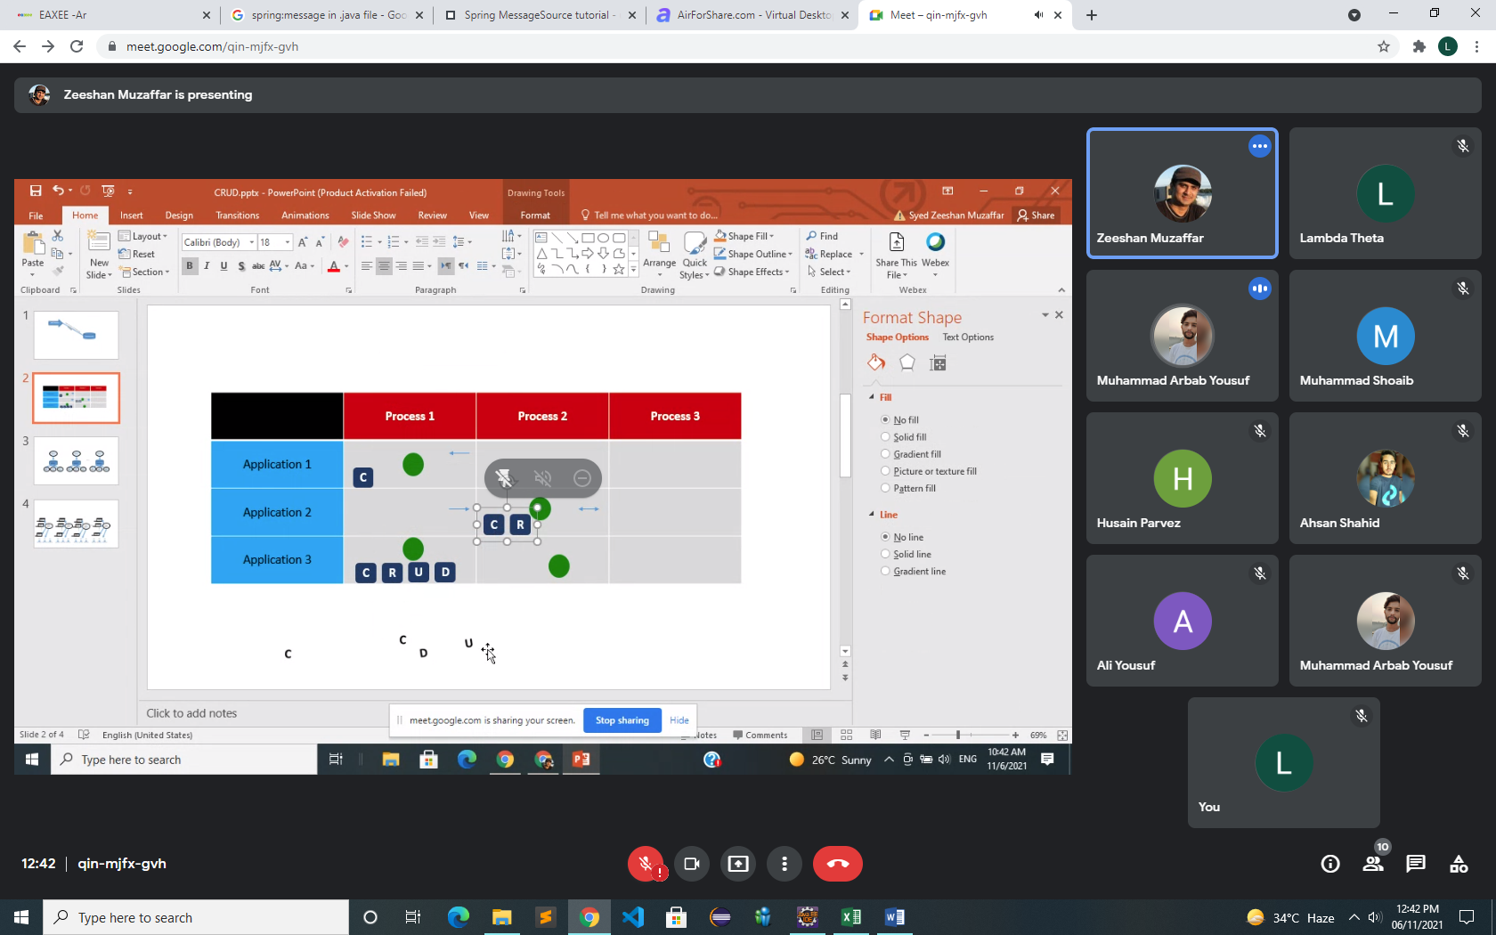

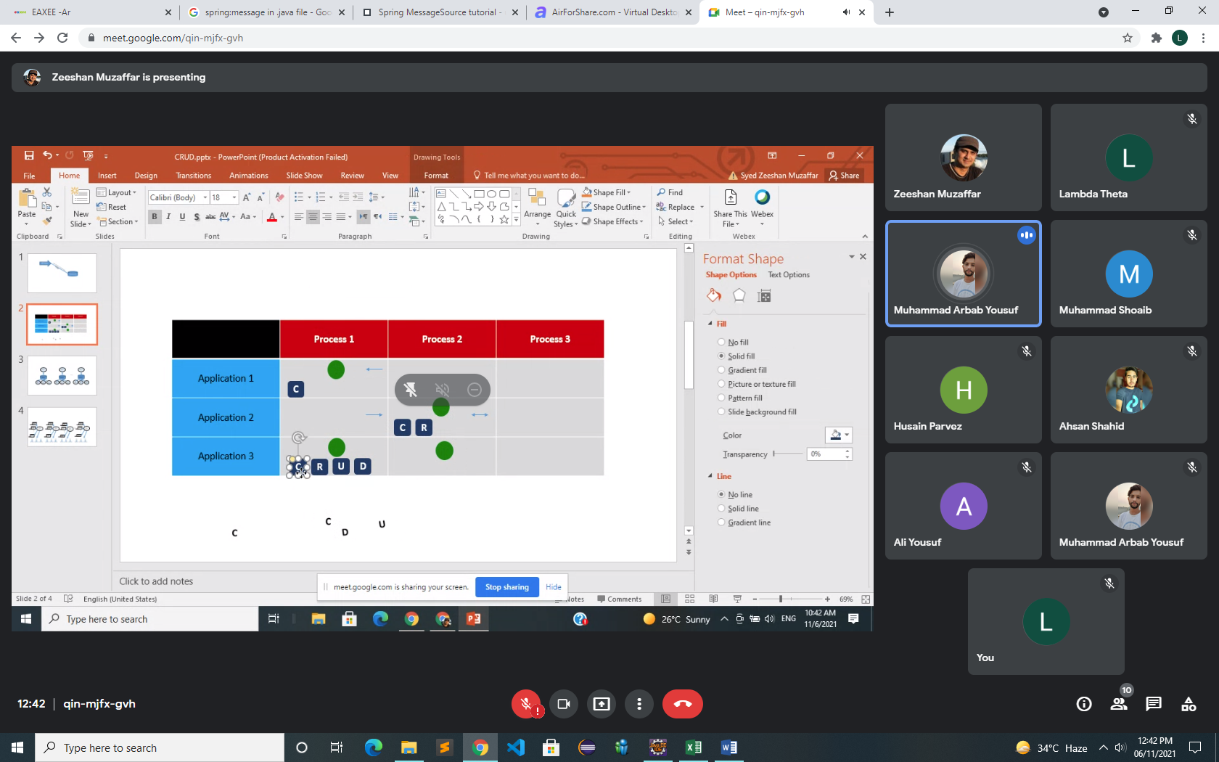

[9:09 AM, 11/22/2021] LT Sir Husain: AoA EAXEE team,

1) Ali to work on the user management tasks full time. Ali please send me the status of task by the end of today.

2) Ahsan, Arbab and Shoaib must work on new tasks in the first half, and in the second half they should complete their previous tasks.

3) Shoaib, your new task is the completion of Meta Modeler that previously was developed by Hussain. Please contact Ahsan to get the past code of Meta Modeler. Execute the code and let me know the status of the code. This Meta Modeler will basically generate the Meta Model Excel file.

4) Ahsan and Arbab, your new task is to work on Organizational portal. The organizational portal will show the charts and graphs.

Arbab should find any open source tool that can draw excellent quality charts. The open source tool should support drawing of the standard charts (bar, spiral, line, 2D, 3D, radar, bubble etc). Draw these charts using a dummy data for the time being.

Ahsan, you need to work on the main page which will show the graphs. The main page will allow adding Tabs. Add new Tab should create a Tab button on the top of the page. The Tab should be in the same way we have Tabs in Excel sheet at the bottom. User can name, rename the Tab. Inside each Tab, the entire full page may have rows and columns (say 3 columns, and any number of row). Each cell will display a chart. The add/delete button will add or remove a chart. There should be drag options so that we may drag a chart from one cell to another. Upon clicking any chart, the chart should display in full screen mode. Each full screen chart can be exported as png/jpg file.

[9:10 AM, 11/22/2021] LT Sir Husain: After this basic GUI is created, we will later work on the query generator, which will basically link the charts with the data in the database. However, for the time being, we need to show the charts for dummy data only.

[9:12 AM, 11/22/2021] LT Sir Husain: It is very important to get really excellent quality charts, and the overall quality of the webpage should be really professional. These things matter a lot in good marketing of the product.